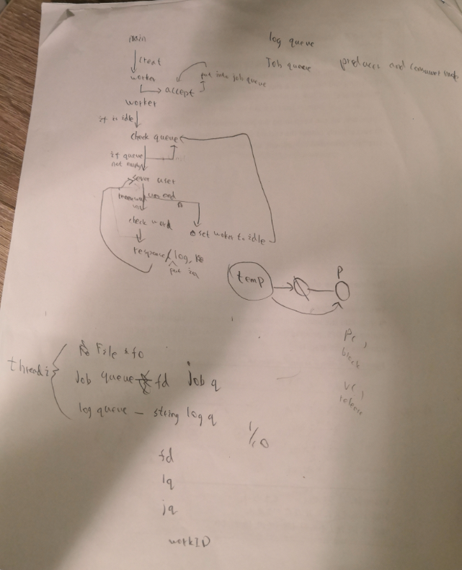

For Project 3:

Server:

**3 thread are required.**

Main thread: initial all the set up such as network, creating worker thread, log thread.

Worker thread: communicate with client and check the word from the client. All created worker threads much be reusable

Log thread: print the result into log file.

**Two queue is required** (log queue and sock_fd queue) and these queue need to use synchronization:

Log queue: store the result and waiting for print out in the log file

Sock_fd queue store any clients which want to connect with the serve and wait for worker to access these clients.

For the thread, it also need a struct(threadi) to transfer data from main thread to log thread or worker thread.

Set workthread() and logthread to static to make sure that only can see in the file.

main()

workthread() // using for creating worker thread and communicate with client

spellcheck () // using for verify the word

connectResult() // connect

logthread() // print out the result into log file

the method below is supported for the queue

initQueue()

Destroy_List()

appendPQ()

appendPQ2()

popF()

Size_List()

listIsEmpty()

Client:

Set up the network and communicate with sever.